# Developer Diary

# By: Rachel McClelland

# ID: G00337231

# Customer: Andrius Korsakas

# Design Pattern

This game can be played on both computer and mobile devices. The design document that I was given was originally just mobile. I decided to add in playing ability on computer devices as well to make the game more multi platformed. There was not a lot of changes that needed to be done to implement this. What I had to add was movement to the game when the player presses the left or right arrow on the keyboard. When using a mobile device, the player can tap the bottom left or bottom right of the screen to move the player left or right respectively.

I decided to only add music to the game when the user shoots or collides with an enemy and loses a life. This was a decision that I made as I felt that background music is too much and would overcrowd the game.

The game was easier to design for a computer as it could be tested straight away without needing an android device to run the game. Because of this, I created the game mainly for computer use and then added in mobile use at the end when everything was up and running. As there is a keyboard with a computer, you have more options for what you want to do with the game. Whereas, with mobile, all buttons need to be on the screen to allow full use of the game. Therefore, I decided to add a “Pause” button to the bottom of the screen. The reason why I put it at the bottom was it is easy to reach while playing the game.

The scrolling background was what I spent a lot of time on. I found a YouTube video online that goes through steps on how to create it [2], but the background kept glitching when it was attempting to repeat the image. I then decided to change it to what was done in the labs during the semester.

## Game Play

The game begins in the from a scene called MainScene. This screen gives the player different options for what they want to do. There are three buttons; “New Game” which allows the user to start a new game, “Credits” to view details about the game and “Quit Game” which allows the user to exit the game.

Once the user clicks “New Game” they will be brought to GameSceneL1. I decided to allow the user to play this level for two minutes. The reason why I picked two minutes is because when I was testing it, it felt like the right about of time to have the game start of on. On entering this level, the player will have a waiting time before the enemies start to fall. The first enemy will be a simple falling enemy that the player must avoid by moving their player object to either the left or the right. After 30 seconds the second enemy will be added into the game. This enemy will be able to shoot a bullet once in the game that the player must also avoid.

If the player is unable to avoid either enemy or a bullet, they will lose a life. The player gets three lives per level. To add more to the game, I decided that once the player has only one life left, they will be able to shoot a bullet which will destroy any enemy that it hits. It does not destroy their bullets.

After two minutes is up the player will be brough to level 2, which is called GameSceneL2, this level is similar, but the movement of the enemies will have sped up. This level will last for 2 and a half minutes and if the player is able to stay on this level for this amount of time, they will then be brought to level 3. The final level is called GameSceneL3.

## Control Mechanisms

Left arrow key – player moves to the left

Right arrow key – player moves to the left

Bottom left hand corner – player moves to the left (for computer and mobile use)

Bottom right hand corner – player moves to the right (for computer and mobile use)

“P” button – game can be paused and un-paused. Game can also be paused by pressing pause button at bottom of the screen

“M” button – sound can be muted when using a computer. Alternatively, the sound can also be muted from the pause menu.

Space Bar – allows the player to shoot when on one life

# Diary

After receiving the design document for this game, Andrius first got in contact with me on the 29th September, by email, and sent me an updated version of the document which included just a mobile version of the game. This was later changed to computer and mobile devices.

After reading through the design document, I then met Andrius after one of our lectures to talk about sprites. Andrius stated he would get them ready and email them to me. Andrius emailed all the sprites on the 8th of October. The sprites included all background images, two enemy images, a player object and a bullet that one of the players will be shooting. One the same day, I emailed Andrius back confirming what multiple background images will be used for. Andrius replied saying that if needed, a different background image can be used for each level to allow the player to differentiate between all levels.

While developing the game, I noticed that the design document had images of the main menu screen where 3 buttons are being displayed. The sprites folder did not contain any button images for me to use. Before emailing Andrius again, I done some research into how I could create my own buttons, where I found this website [1]. On this website you can create a button however you would like and download it as a PNG file so that I can be used in the game. Before adding them to the game, I emailed Andrius on the 29th October to find out if he had already created the buttons for me. I also shared the link to him to show him what I had found. Andrius replied on the 1st November to say that I can use the website I had found.

By the 3rd December, I had most of the game created but I had a few questions for Andrius about how the game should work. I decided to email Andrius once again to find out how many lives the player should get in each level, how should the score be calculated and what is the time that the player should be able to play each level for. Andrius replied to my questions saying each level the player should have three lives, the score is based on how many lives the player has remaining at end of the game. For the time part, Andrius let me decide how I would like to implement in, for example, between 2 – 4 minutes per level.

# Test Plan

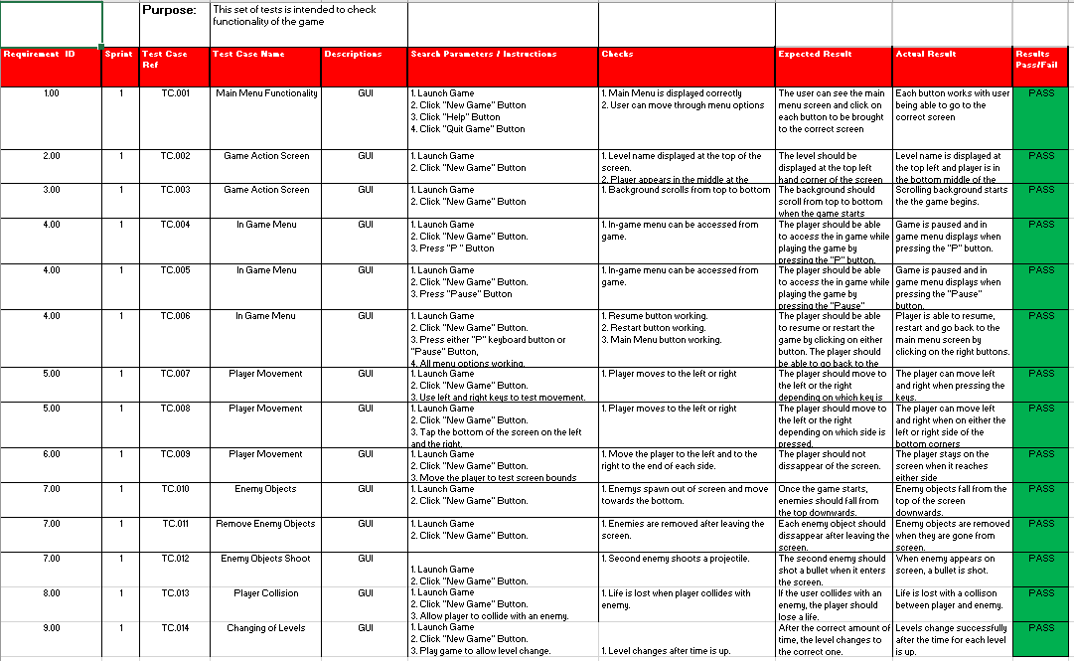

# Scenes

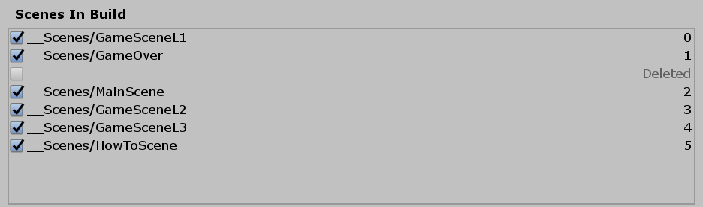

# Github Link

<https://github.com/rachelmcclelland/MobileApp3-Project>

# References

[1] Da Button Factory - <https://dabuttonfactory.com/>

[2] Unity 5 2D - Endless scrolling background - Vertical & Horizontal - <https://www.youtube.com/watch?v=je1ZHOn3my4>

<https://answers.unity.com/questions/1173303/how-to-check-which-scene-is-loaded-and-write-if-co.html>

Sounds from - <https://freesound.org/>

Help Images - <https://www.iconfinder.com/iconsets/keyboard-11>

How to Pause and Un-Pause - <https://www.sitepoint.com/adding-pause-main-menu-and-game-over-screens-in-unity/>